1. Use `pwd`, `ls`, `cd` to explore the file system and display current location.
Ans. 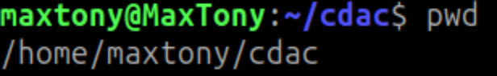

2. Create directories `lab1/lab2/lab3` using one command.
Ans.
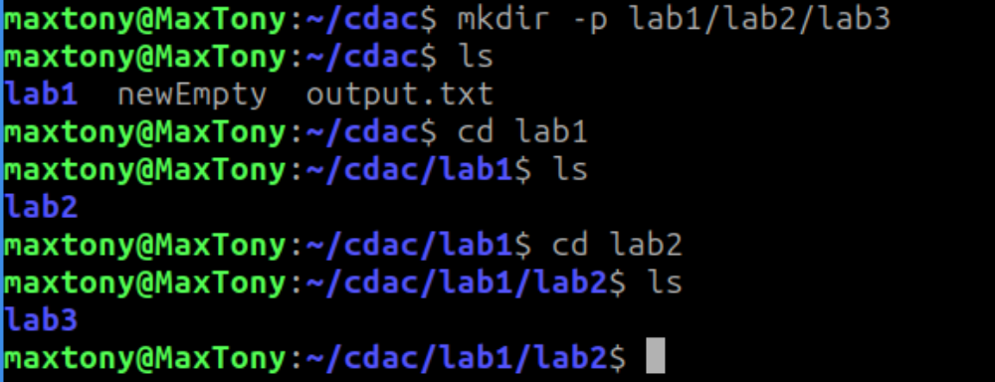

- Create 10 files (`file1` to `file10`) inside `lab3` using one command.
Ans. 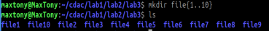

- Display who is logged in with `who`, and the current user with `whoami`.
Ans. 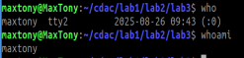

- Use `ps` to list your processes and `kill` to terminate one.
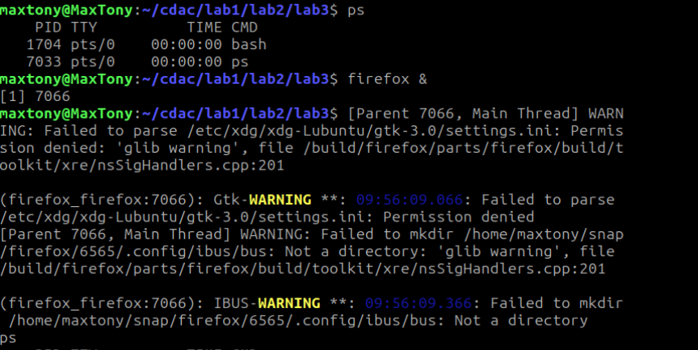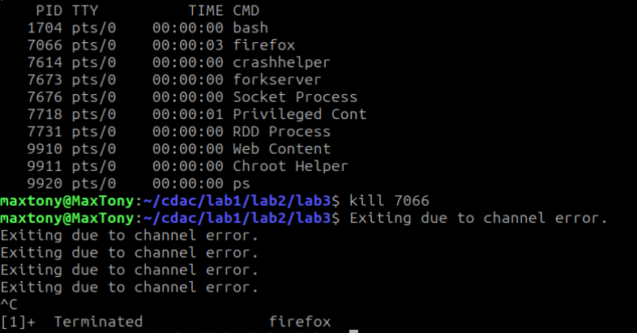

- Create 50 files `data1` to `data50` inside a directory with a single command.
Ans.

- Copy all `.txt` files from one folder to another using wildcards.
Ans. 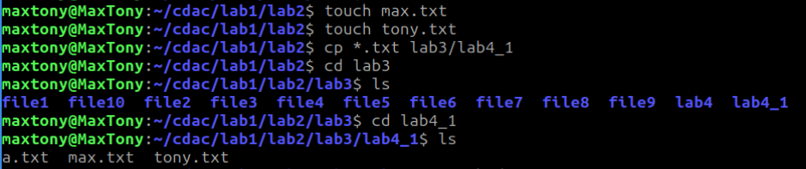

- Use `cat`, `less`, `head`, `tail` to view file contents.
Ans. 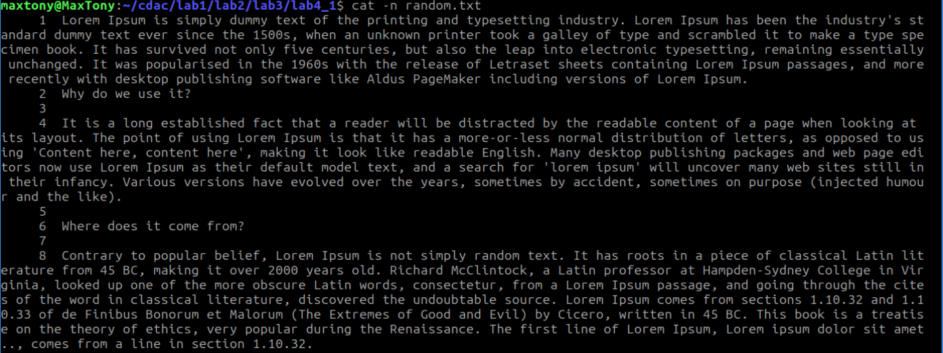

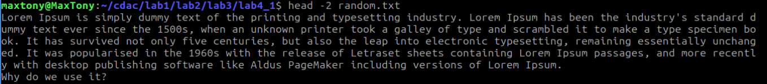
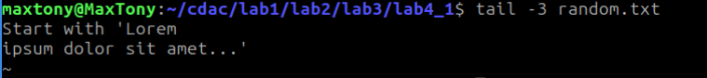

- Write a small C program and compile it using a `Makefile`.
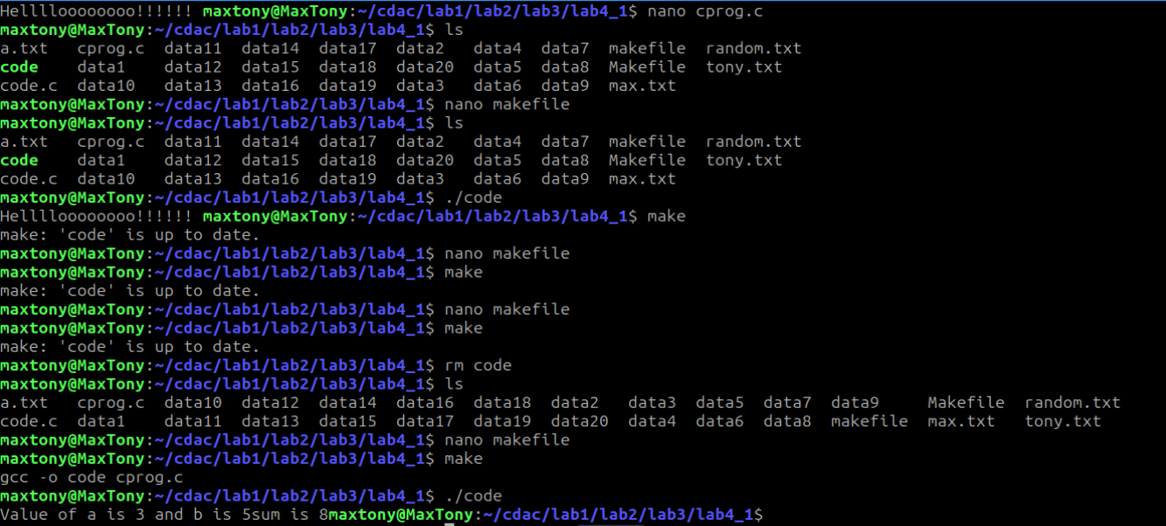

10. Redirect the output of `ls -l` to a file and append the date to it.

